# Bug 1 Test Investigation/Fix Log

## Hypothesis

That the method Game.playround() is the source of the bug as it calculates the winnings in each turn of play.

## Action

Place breakpoints into the Game.playround() method to observe the content of variables for winnings and balance.

## Results

Investigation into Bug 1 shows that the balance is increased by the winnings when there is one match against a die. The balance is then reduced in the next turn when the value of the bet is subtracted from the player’s balance (which is correct). This means that the program is behaving correctly. See screenshots below:

Screenshot 1 – code in receiveWinnings() method shows balance at $25, winnings at $5:

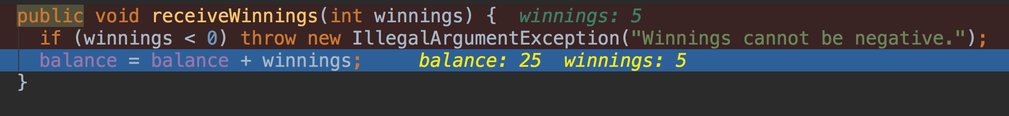

Screenshot 2 – variables reflect winnings:

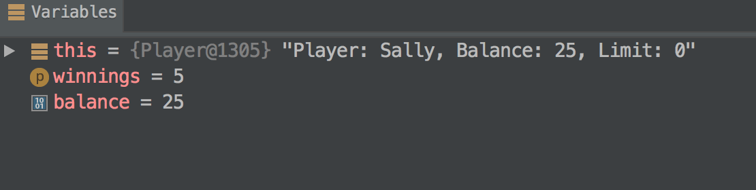

Screenshot 3 – code in receiveWinnings() method shows balance at $30 after including previous winnings:

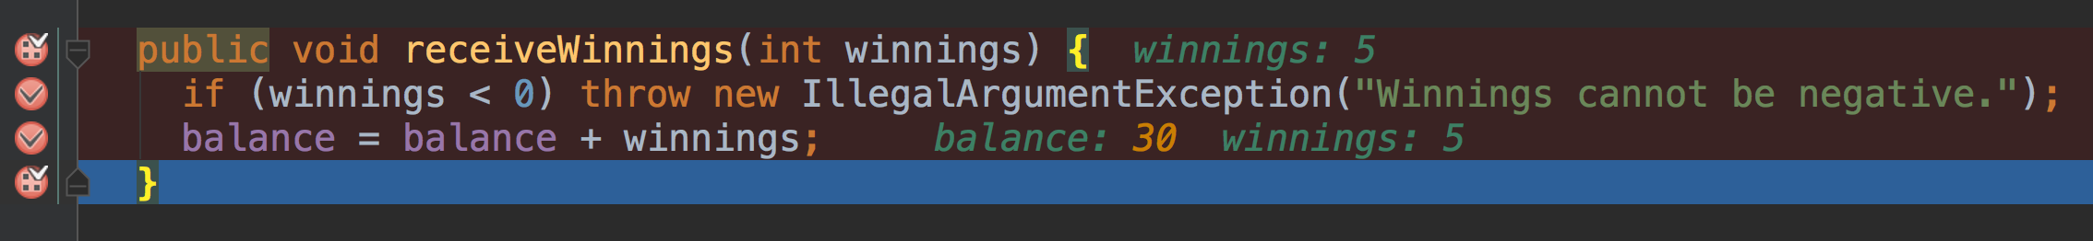

Screenshot 4 – variables reflect winnings increasing the player’s balance:

